ER diagram

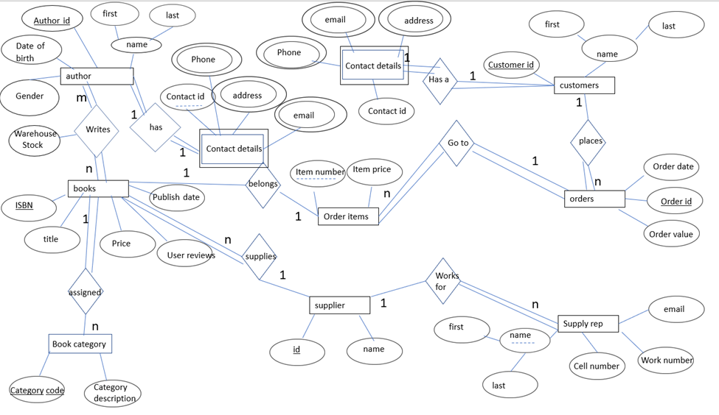

Relational Schema

author(author_id, birthdate, gender, first, last)

Primary key = author_id

books(ISBN, title, price, reviews, publish_date, supplier_id)

Primary key = ISBN

Foreign key = supplier_id

warehouse(authur_id, ISBN, stock)

Primary key = {author_id, ISBN}

Foreign key = {author_id, ISBN}

bookCategory(category_code, category_description, ISBN)

Primary key = category_code

Foreign key = ISBN

supplier(supplier id, name)

Primary key = supplier_id

supply_rep(first, last, cell_number, work_number, email, supplier_id)

Primary key = {first, last, supplier_id}

Foreign key = supplier_id

orders(order_id, order_date, order_value, customer_id

Primary key = order_id

Foreign key = customer_id

customers(customer_id, first, last)

Primary key = customer_id

Foreign key = contact_id

customer_contact_details(contact_id, customer_id)

Primary key = {contact_id, coustomer_id}

Foreign key = customer_id

customer_number(phone, contact_id, customer_id)

Primary key = {contact_id, coustomer_id}

Foreign key = {contact_id, coustomer_id}

customer_email(email, contact_id, customer_id)

Primary key = {contact_id, coustomer_id}

Foreign key = {contact_id, coustomer_id}

customer_address(address, contact_id, customer_id)

Primary key = {contact_id, coustomer_id}

Foreign key = {contact_id, coustomer_id}

author_contact_details(contact_id, author_id)

Primary key = {contact_id, author_id}

Foreign key = author_id

author_number(phone, contact_id, author_id)

Primary key = {contact_id, author_id}

Foreign key = {contact_id, author_id}

author_address(address, contact_id, author_id)

Primary key = {contact_id, author_id}

Foreign key = {contact_id, author_id}

author_email(email, contact_id, author_id)

Primary key = {contact_id, author_id}

Foreign key = {contact_id, author_id}

order_items(item_numbers, item_price, order_id, ISBN)

Primary key = {order_id, item_number}

Foreign key = {order_id, ISBN}